**Title:** CS1026 Lab 2 (NOR Gates)

**Date:** 26/10/2017

**Aim:** To design a circuit to implement F = (X + Z)(Y + Z)(X + Y + Z) using only NOR Gates and inverters.

**Logic Diagram:**

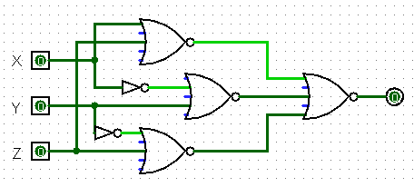

**Analysis:**

* I began by finding the complement of the original function F.
* Then, using DeMorgans Theorm I expanded the function to create a function containing 3 NOR’s.
* Using various Boolean Algebra Simplification theorms I then further expended and simplified out the function until I reached a solution in the end with a single variable.
* Following this I then built and tested the circuit using Logisim to see if it was giving the desired output when the variable Z was set to 1.

**Boolean Algebra:**

**F = (x+z)(y’+z)(x’+y+z)**

F’ = (x+z)’+(y’+z)’+(x’+y+z)’

F = [(x+z)’+(y’+z)’+(x’+y+z)’]’ *DeMorgans*

F = [(x+z)’.(y’+z)’.(x’+y+z)’]’

F = (x’zy’ + x’z + yxz + yz + zyx’ + zxy’ + zx + zy’ + z) *Expanding*

F = z(~~x’y’~~ + ~~xy~~ + ~~x’~~ + ~~x~~ + ~~y’~~ + ~~y~~ + ~~x’y~~ + ~~xy’~~ +z) *Simplification*

F = z(z)

**F = z**